**WEEK 7:**

create database 043_supplier;

use 043_supplier;

create table 043_supplier.Supplier(

sid int,

sname varchar(15),

city varchar(10),

PRIMARY KEY(sid)

);

create table 043_supplier.Parts(

pid int,

pname varchar(10),

color varchar(5),

PRIMARY KEY(pid)

);

create table 043_supplier.Catalog(

sid int,

pid int,

cost int,

PRIMARY KEY(sid, pid),

FOREIGN KEY(sid) REFERENCES Supplier(sid),

FOREIGN KEY(pid) REFERENCES Parts(pid)

);

insert into Supplier values(10001,"Acme Widget", "Bangalore");

insert into Supplier values(10002,"Johns", "Kolkata");

insert into Supplier values(10003,"Vimal", "Mumbai");

insert into Supplier values(10004,"Reliance", "Delhi");

insert into Parts values(20001,"Book", "Red");

insert into Parts values(20002,"Pen", "Red");

insert into Parts values(20003,"Pencil", "Green");

insert into Parts values(20004,"Mobile", "Green");

insert into Parts values(20005,"Charger", "Black");

insert into Catalog values(10001,20001, 10);

insert into Catalog values(10001,20002, 10);

insert into Catalog values(10001,20003, 30);

insert into Catalog values(10001,20004, 10);

insert into Catalog values(10001,20005, 10);

insert into Catalog values(10002,20001, 10);

insert into Catalog values(10002,20002, 20);

insert into Catalog values(10003,20003, 30);

insert into Catalog values(10004,20003, 40);

select * from Supplier;

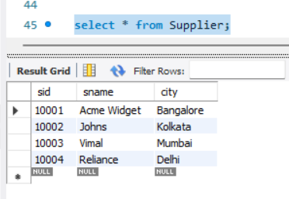

select * from Parts;

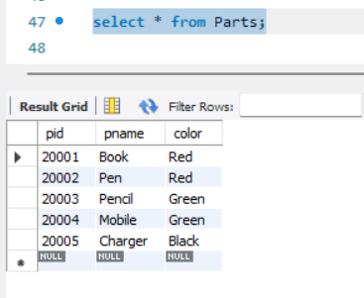

select * from Catalog;

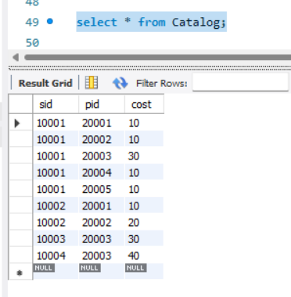

select distinct p.pname

from Parts p, Catalog c

where p.pid = c.pid;

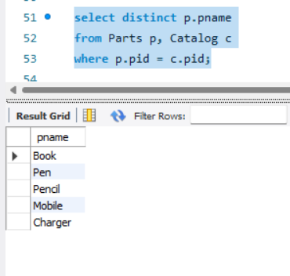

SELECT distinct s.sname

FROM Catalog C, Supplier s WHERE C.sid=s.sid and NOT EXISTS (SELECT P.pid FROM Parts P

WHERE NOT EXISTS (SELECT C1.sid FROM Catalog C1

WHERE C1.sid = C.sid and C1.pid = P.pid));

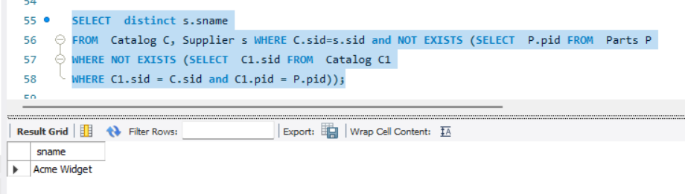

SELECT distinct s.sname

FROM Catalog C, Supplier s WHERE C.sid=s.sid and NOT EXISTS (SELECT P.pid FROM Parts P

WHERE P.color="Red" and NOT EXISTS (SELECT C1.sid FROM Catalog C1

WHERE C1.sid = C.sid and C1.pid = P.pid and P.color="Red"));

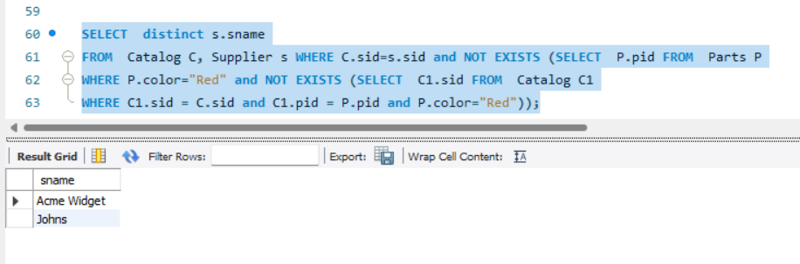

select P.pname

from Parts P, Catalog C, Supplier S

WHERE P.pid = C.pid and C.sid = S.sid and S.sname = "Acme Widget"

and NOT EXISTS (select * from Catalog C1, Supplier S1

WHERE P.pid = C1.pid and C1.sid = S1.sid and

S1.sname != "Acme Widget");

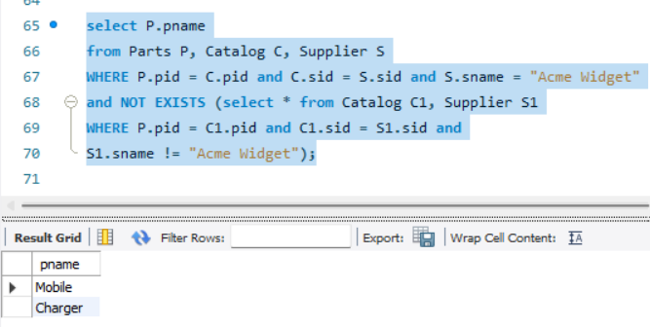

SELECT DiSTINCT C.sid FROM Catalog C

WHERE C.cost > (SELECT AVG(C1.cost)

FROM Catalog C1 WHERE C1.pid = C.pid);

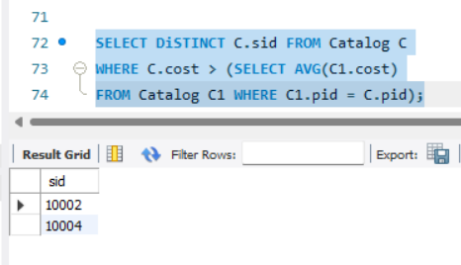

SELECT P.pid, S.sname

FROM Parts P, Supplier S, Catalog C

WHERE C.pid = P.pid AND

C.sid = S.sid AND

C.cost = (SELECT MAX(C1.cost)

FROM Catalog C1

WHERE C1.pid = P.pid);

